**Lab 1 – Digital Logic Gates**

Faizan Bangash

TA : Saurav Kumar Sahu

ECEN 248 – 302

June 12th, 2018.

**Objective –**

In this lab, I learned how NOT, OR, NOR, AND, NAND, and XOR gates worked more in depth. Using a breadboard, the gates, some wires, and a multimeter, we measured the outputs for different gates for given inputs. Additionally, the lab teaches basic knowledge of a breadboard as well as multiple other tools such as the multimeter.

**Design –**

The design for each circuit are listed below. In this lab we had to use TI 7400 series dual inline package. For most 7400 series boards, they follow this pin diagram.

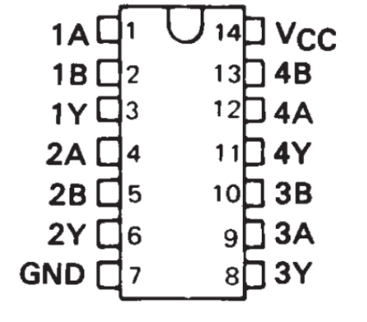

In the diagram above A and B are the inputs and Y is the output and we want to make sure that we connect the Vcc pin to the positive end of the power supply set on 5 V and the ground pin to the ground end power supply.

The design for Not gate is as follow and Not gate only takes one input where as all other gates take two inputs.

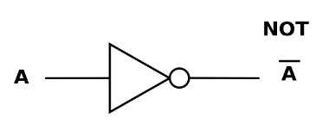

**OR gate:**

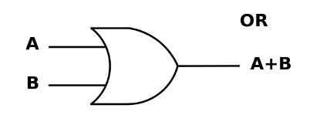

**Nor Gate:**

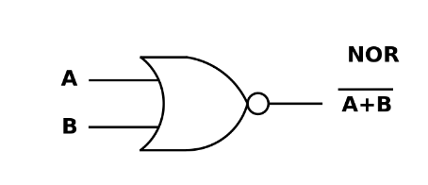

**AND Gate:**

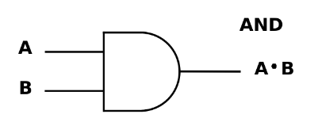

**NAND Gate:**

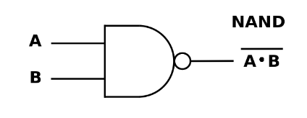

**XOR Gate:**

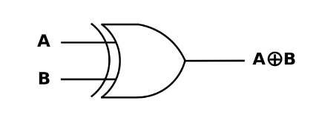

**Results –**

The results I got were expected for the gate I used, and the following logic tables are as follows:

NOT GATE

|  |  |  |
| --- | --- | --- |
| Input( High/Low) | Output (V) | Output (High/Low) |
| High | 45.2 mV | Low |
| Low | 4.02 V | High |

AND and OR gate:

|  |  |  |  |  |  |
| --- | --- | --- | --- | --- | --- |
| Input A (High/Low) | Input B (High/Low) | AND2 (V) | AND2 (High/Low) | OR2 (V) | OR2 (High/Low) |
| L | L | 106.5 mV | L | 49.9 mV | L |
| L | H | 106.2 mV | L | 4.01 V | H |
| H | L | 106.1 mV | L | 4.01 V | H |
| H | H | 4.43 V | H | 4.01 V | H |

NAND ,NOR, and XOR gates:

|  |  |  |  |  |  |  |  |
| --- | --- | --- | --- | --- | --- | --- | --- |
| Input A (High/Low) | Input B (H/L) | NAND2 (V) | NAND2 (H/L) | NOR2 (V) | NOR2 (H/L) | XOR (V) | XOR(H/L) |
| L | L | 4.10 V | H | 4.08 V | H | 157.8mV | L |
| L | H | 4.10 V | H | 70.6 mV | L | 4.44 V | H |
| H | L | 4.10 V | H | 70.1 mV | L | 4.43 V | H |
| H | H | 114.2 mV | L | 70.1 mV | L | 167.5 mV | L |

**Conclusion –**

In the lab, I connected a breadboard up to a voltage source, then wired the breadboard in order to test the logic behind each gate. I connected the black lead of the multimeter to the ground, and the red lead of the multimeter to the Y output leg of each gate to test the output of each gate. The results I got match the theoretical answers of each gate. From this lab, I gained more knowledge about how breadboards work as well as enhanced my knowledge about logic gates. This will be important for future labs as breadboards are one of the most used tools in the lab.